

SPARKY ENTERTAINMENT INDIA PVT. LTD

# **Interview Assessment Form**

**To be filled by the candidate**

**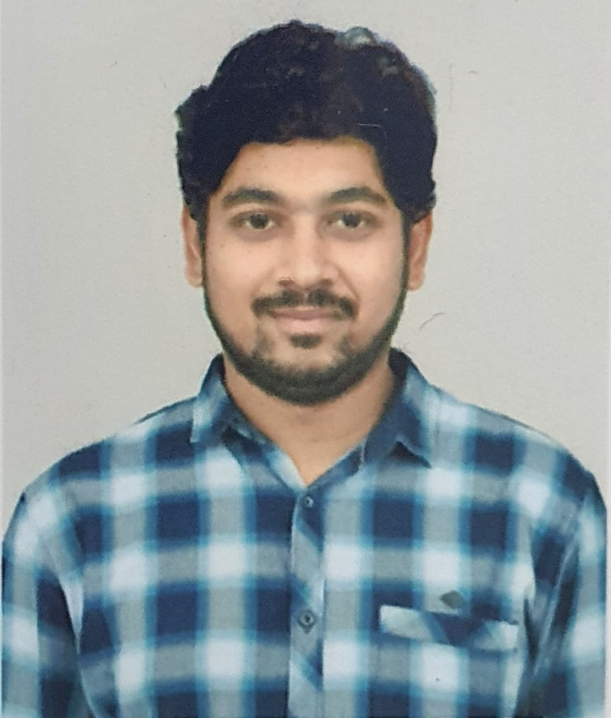**

|  |  |
| --- | --- |
| **Position Applied for:** | **3D Animator** |

|  |  |  |  |  |  |
| --- | --- | --- | --- | --- | --- |
| **1. Name:** | **VINAY KUMAR** |  |  |  | **MARKONDA** |
|  | (First Name) |  | (Middle Name) |  | (Surname) |

|  |  |  |  |  |  |  |  |
| --- | --- | --- | --- | --- | --- | --- | --- |
| **2. Date of Birth:** | **19-09-1995** |  | **3. Age:** | **28** |  | **4. Gender:** | **MALE** |

|  |  |  |  |  |
| --- | --- | --- | --- | --- |
| **5. Marital Status:** | **MARRIED** |  | **6. No. of Children:** | **NO** |

|  |  |  |  |  |
| --- | --- | --- | --- | --- |
| **7. Email ID:** | **VINAYMARKONDA@GMAIL.COM** |  | **8. Skype ID:** | **live:.cid.4026b2de4cccc2bd** |

|  |  |
| --- | --- |
| **9. Mobile No:** | **8143081696** |

|  |  |
| --- | --- |
| **10. Present Address** | **11. Permanent Address** |
| 13-1-240/PLOT-177, Door No- 506, SWAGRUHA MOTI APTS, MOTHI NAGAR,NEAR I O B HYDERABAD, TELANGANA 500018 | 13-1-240/PLOT-177, Door No- 506, SWAGRUHA MOTI APTS, MOTHI NAGAR,NEAR I O B HYDERABAD, TELANGANA 500018 |

**12. Work Experience (Please list your current employer first, along with your previous 2 employers)**

|  |  |  |  |  |  |
| --- | --- | --- | --- | --- | --- |
| **Name of the Company/Firm and Location** | **Month & Year** | | **Monthly Salary (CTC)** | **Designation** | **Reason for Leaving** |
| ASSEMBLAGE ANIMATION STUDIOS | **From:** | DEC-2021 | 65000 | **3D Animator** | CAREER GROWTH |
| **To:** |  |  |
| XENTRIX ANIMATION STUDIOS | **From:** | NOV-2020 | 46000 | **3D Animator** | CAREER GROWTH |
| **To:** | DEC-2021 |  |
| YUVA ANIMATION STUDIOS | **From:** | FEB-2017 | 25000 | **3D Animator** | CAREER GROWTH |
| **To:** | OCT-2020 |  |

|  |  |  |
| --- | --- | --- |
| **13. Total Years of Working Experience:** | 6.4 |  |

|  |  |  |  |
| --- | --- | --- | --- |
| **14. Current Drawn Monthly Salary (CTC)** | **\_\_\_65,000\_\_\_\_\_\_\_** | **15. Expected Monthly**  **Salary (CTC):** | **\_\_\_\_\_80,000\_\_\_** |
| **16. Starting Date of Last Drawn Salary** | **\_\_\_04-Nov-2023\_\_\_** |  |  |

|  |  |  |
| --- | --- | --- |
| **17. Upon being offered with a job, please list the earliest date of commencement:** | **30** | **days** |

|  |
| --- |
| **18. Consumption of any prescribed medication? ( Yes / No ) \***  **If Yes, please list the name of the drug along with reasons for consumption: NO** |

|  |  |
| --- | --- |
| **19. Have you ever been convicted of a criminal offence?** | **NO** |
| **20. Have you ever been in police custody / arrested?** | **NO** |

**Declaration:**

I authorize investigation of all statements contained in this application. I understand that misrepresentation or omission of facts called for, is cause for dismissal.

|  |  |  |  |  |  |
| --- | --- | --- | --- | --- | --- |
| **Signature of Applicant:** | **C:\Users\hp\Downloads\Vinay_Signature1.jpg** |  | **Date:** | **16-11-2023** |  |